Lab7

1) 

n = int(input('n = '))  
a = [list(map(float, input().split())) for i in range(n)]  
a = a[::2]  
a = [el[::2] for el in a]  
a = [[el1 for el1 in el if el1 < 0] for el in a]  
s = 0  
for i in range(len(a)):  
 s += len(a[i])  
print('Кількість таких елементів = {0}'.format(s))

Приклад:

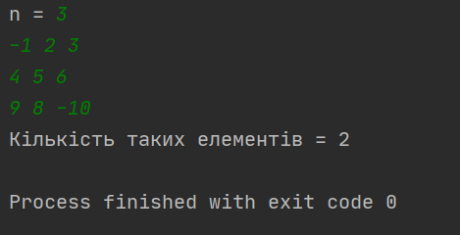

2)

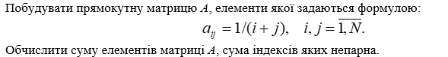

ni = int(input('i = '))  
nj = int(input('j = '))  
a = [[1/(i+j) for j in range(1, nj+1)] for i in range(1, ni+1)]  
a = [[a[i][j] for j in range(nj) if (i+j) % 2 == 1] for i in range(ni)]  
s = 0  
s = sum([sum(el) for el in a])  
print('Сума елементв = {0}'.format(s))

Приклад:

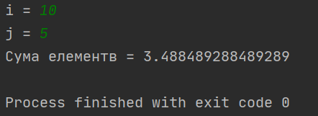

3)



n = int(input('n = '))  
a = [list(map(float, input().split())) for i in range(n)]  
b = a + []  
for i1 in range(1, n):  
 for i in range(i1, n):  
 k = b[i][i1-1] / b[i1-1][i1-1]  
 for j in range(n):  
 b[i][j] = b[i][j] - k * b[i1-1][j]  
for i in range(n):  
 print(b[i])

Приклад:

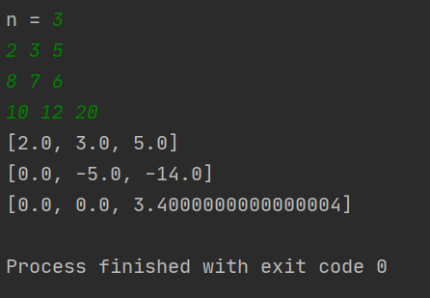

4)



n = int(input('n = '))  
a = [list(map(float, input().split())) for i in range(n)]  
b = [a[i][i] for i in range(n)]  
b.sort()  
for i in range(n):  
 a[i][i] = b[i]  
 print(a[i])

Приклад:

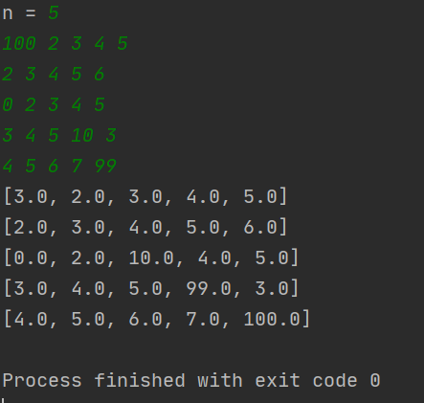

5)

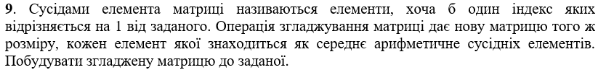

def element_neighbors(i, j):  
 d = [a[i][j]]  
 if i+1 < n:  
 d.append(a[i+1][j])  
 if i-1 > -1:  
 d.append(a[i-1][j])  
 if j+1 < n:  
 d.append(a[i][j+1])  
 if j-1 > -1:  
 d.append(a[i][j-1])  
 return sum(d)/len(d)  
  
  
n = int(input('n = '))  
a = [list(map(float, input().split())) for i in range(n)]  
b = [[element_neighbors(i, j) for j in range(n)]for i in range(n)]

for k in range(n):  
 print(b[k])

Приклад:

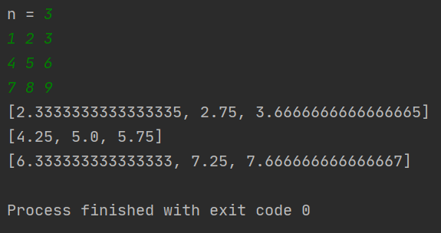

6)

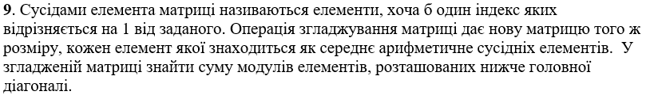

def element_neighbors(i, j):  
 d = [a[i][j]]  
 if i+1 < n:  
 d.append(a[i+1][j])  
 if i-1 > -1:  
 d.append(a[i-1][j])  
 if j+1 < n:  
 d.append(a[i][j+1])  
 if j-1 > -1:  
 d.append(a[i][j-1])  
 return sum(d)/len(d)  
  
  
n = int(input('n = '))  
a = [list(map(float, input().split())) for i in range(n)]  
b = [[element_neighbors(i, j) for j in range(n)]for i in range(n)]

for k in range(n):  
 print(b[k])  
s = 0  
for i in range(n):  
 s += sum(b[i][:i])  
print('Сума елеменетів ниже головної діагоналі згладженої матриці = {0}'.format(s))

Приклад:

